**A PROJECT REPORT**

**ON**

**MEASURING SUCCESS IN TALENT MANAGEMENT**



**Session:2021 to 2024**

**Department of B.sc Mathematics**

**MMES Womens Arts And Science Collage.**

**Hakeem Nagar, Melvishram.**

**Submitted to: Submitted by:**

**Yogambigai A. Nanthini (34621U25012)**

**Head of Department M. Pramiladevi(34621U25014)**

**Y. Farheen (34621U25003)**

**U. Thaseen Nishath (34621U25023)**

**G. Swetha (34621U25022)**

**CERTIFICATE**

This is certified that project untitled

**MEASURING SUCCESS IN TALENT MANAGEMENT**

B.Sc 3rd year, Mathematices, MMES Womens Arts And Science Collage, Hakeem Melvisharam. For award of the

Bachelor in Science, is a bonafide record of work carried out by them under guidance of **Yogambigi**

**MEASURING SUCCESS IN TALENT MANAGEMENT**

INTRODUCTION

OVERVIEW:

Talent Management starts with identification of the appropriate skilled people required for the organization and then there is proper selection of people with requisite potentials and skills in desired job.

After identification and selection of the right kind of people, Talent Management implements competitive compensation that may include attractive pay-package, periodical increment, health insurance, paid leaves, etc. for the employees. The selected workforce is provided with training and regular refreshment programs so as to match the emerging requirements of the organization.

The basic purpose of talent management is to recruit, develop, and retain best talent in the organization. The HR Department always endeavors to ensure that employees with the right skills and qualities stay with the organization for a long time.

A requisite pool of qualified and talented employees can simplify the process of achieving the organizational goal and help focus on issues that really matters in the interest of the organization. Therefore, the overall purpose of talent management is to maintain a skilled and efficient workforce for the organization.

In modern-day organizations, the importance of talent management is second to none. Unless an organization has the required talented workforce, it cannot succeed in attaining its goal even if it possesses other factors such as natural resources, infrastructure, and technology. In fact, it is people who take an organization to its next levels of success.

PURPOSE:

* It helps the organization fulfill its vision with the help of efficient and promising talented people.
* Talent management also assists the organization to build a talent pool comprising a list of talented people to meet future exigencies.
* It helps automate the core processes and helps capture data for making better decisions.
* Automates repetitive tasks like creating salaries thereby releasing time and resources for making strategies and more critical decisions.
* It helps automate the core processes and helps capture
* Establishes better match between jobs and skills.
* Helps retain top talent thereby reducing the cost of hiring new recruits.
* Helps in understanding the employees better.

**PROBLEM THINKING AND DESIGN THINKING**

EMPATHY MAP:

This is the empathy map we done. we include our new strategies.

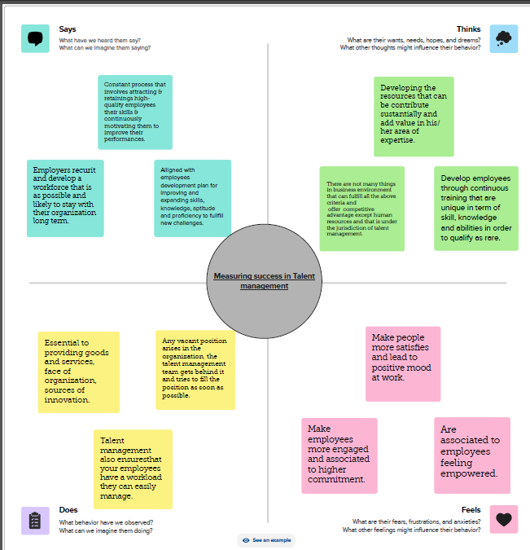

**IDEATION AND BRAINSTORMING MAP**

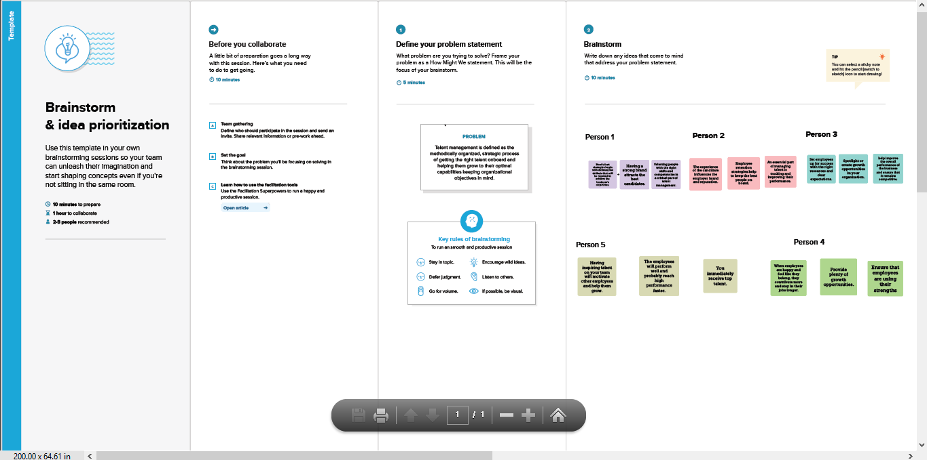

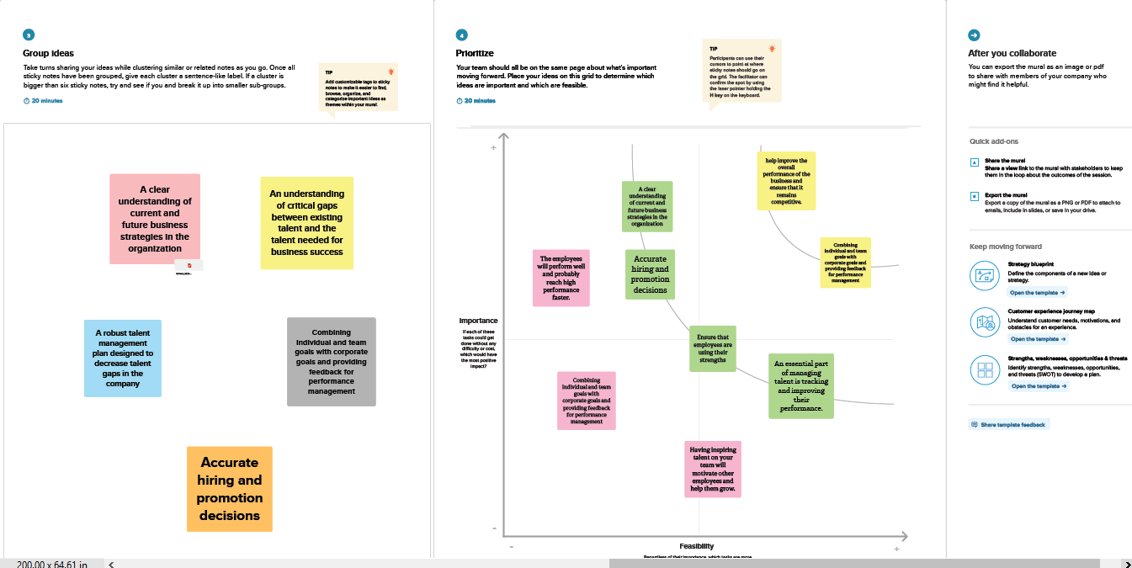

**RESULT**

**This is our dash board we desinged our dash board by various sheets. We analysis various problems from given dataset.**

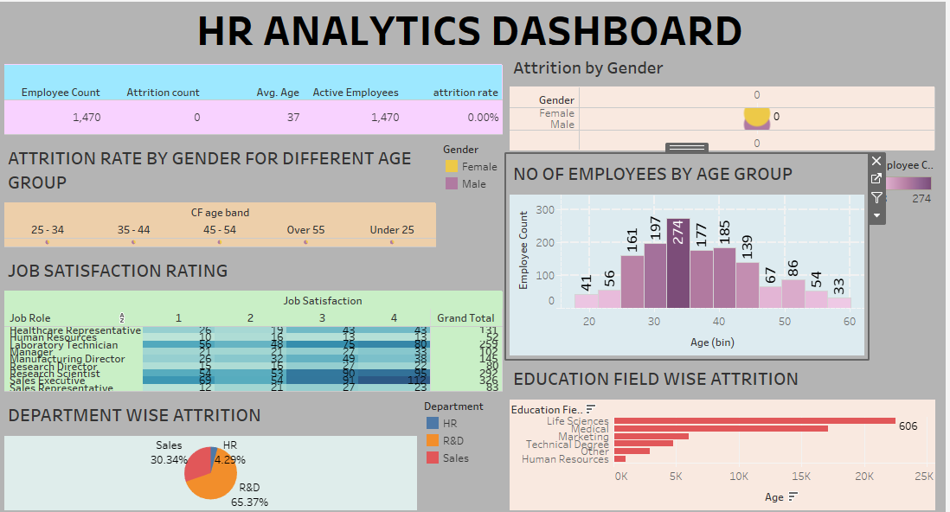

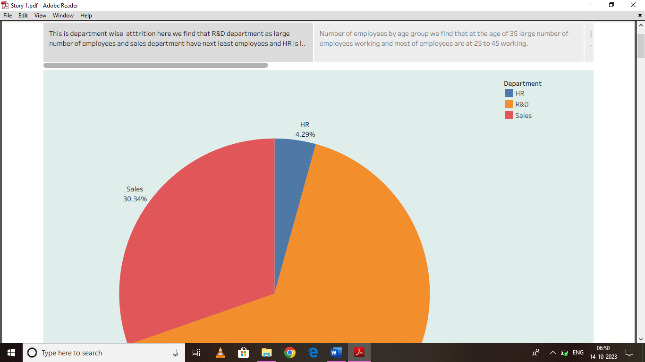

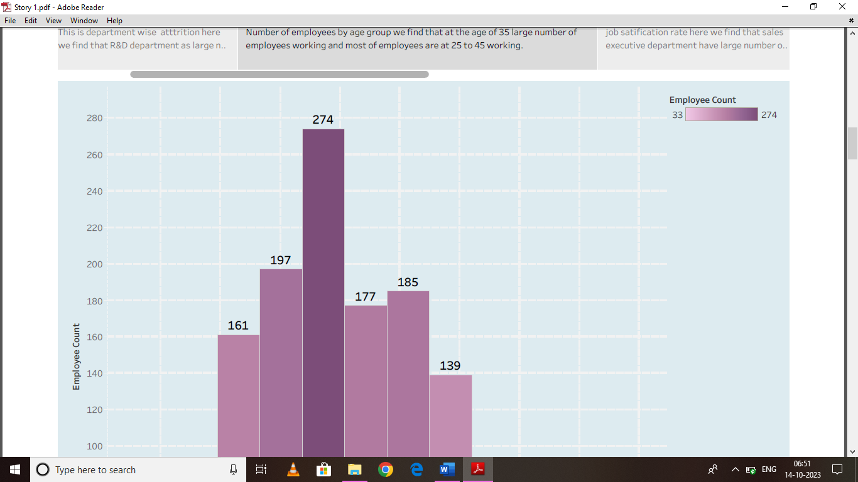

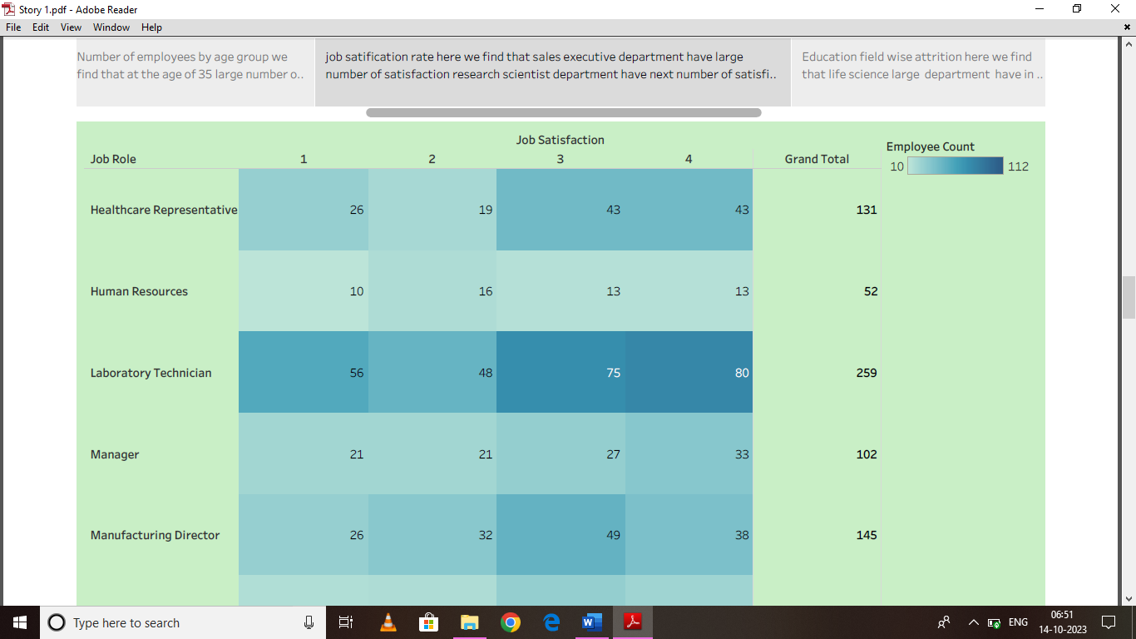

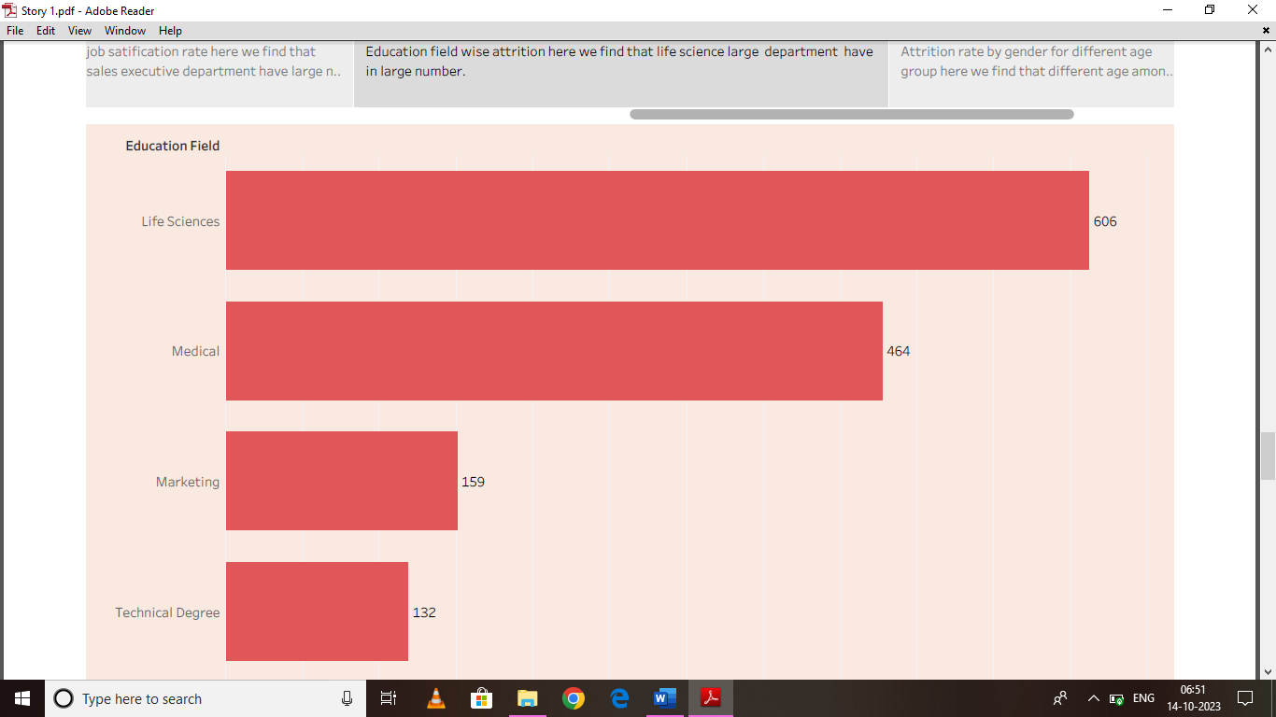

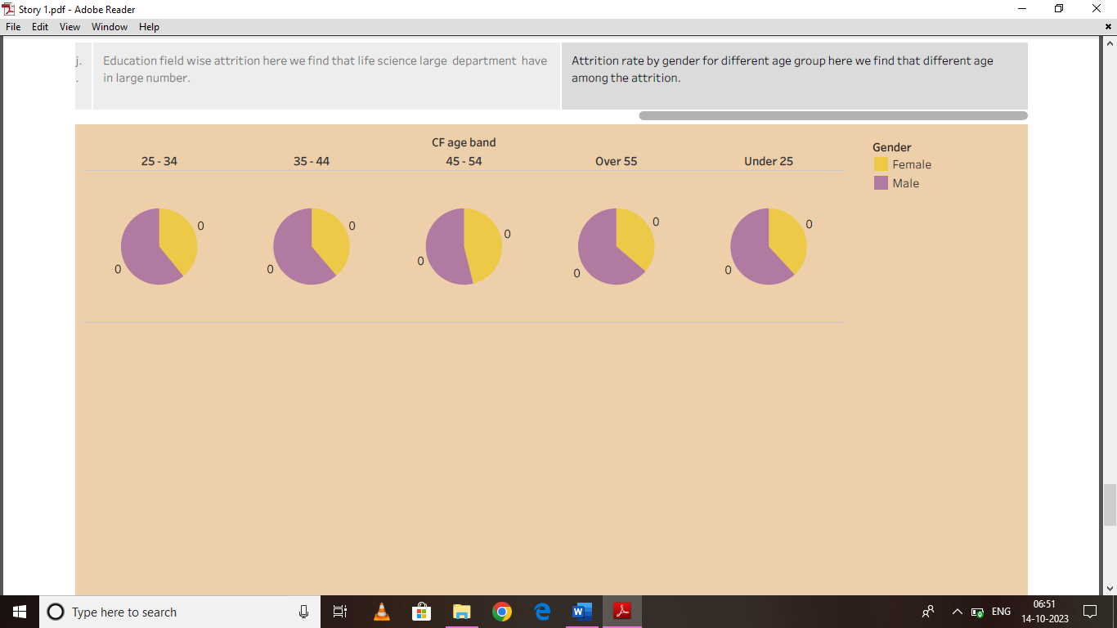

This is our story telling from the vaious sheets we made from data set . This story tell about each sheethas various problem we find solution to this problems.

**ADVANTAGES AND DISADVANTAGES**



**ADVANTAGES**

* Enhances individual and group productivity and capacity to compete effectively in a complex and dynamic environment to achieve sustainable growth.
* Assists in hiring quality workforce.
* Establishes better match between jobs and skills.
* Helps retain top talent thereby reducing the cost of hiring new recruits.
* Helps in understanding the employees better.
* Keeps employees engaged constructively.
* Effective use of available man-hours.
* Helps develop leaders for tomorrow within the organization.
* Helps in evaluating employee’s readiness to take up new roles.

**DISADVANTAGES**

* The implementation of talent management program could be expensive in terms of time, resources and financial costs.
* Lack of support from line mangers can impede the level of commitment from employees.
* A core drawback of talent management is, it can contribute in raising the conflicts between HR and management by not reaching to proper agreement or consensus.

**APPLICATIONS**

The application of this project is we learn how to analysis data by this project and we find different solution in the different areas. We use tableau to analysis the data. We find what are the draw back and advantages while doing the project. The we find solution to this problems.

***CONCLUSION***

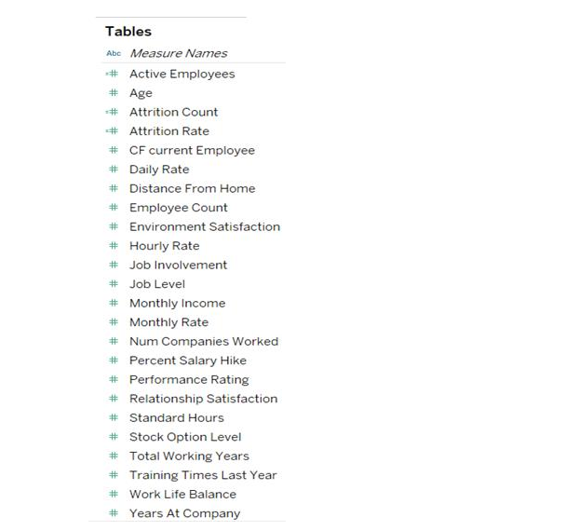

*This is the table data in our data set.*

**Prepare the Data for Visualization** :

Preparing the data for visualization involves cleaning the data to remove irrelevant or missing data, transforming the data into a format that can be easily visualized, exploring the data to identify patterns and trends, filtering the data to focus on specific subsets of data, preparing the data for visualization software, and ensuring the data is accurate and complete. This process helps to make the data easily understandable and ready for creating visualizations to gain insights into the performance and efficiency.

* First we done sheet 1 we find the department wise attrition.
* Second we done sheet 2 we find the number of employees by age group.
* Third we done sheet 3 we find job satisfaction rating.
* Fourth we done education field wise attrition.
* Fifth we done attrition rate by gender for different age group.

Dashboard:

A dashboard is a graphical user interface (GUI) that displays information and data in an organized, easy-to-read format. Dashboards are often used to provide real time monitoring and analysis of data, and are typically designed for a specific purpose or use case. Dashboards can be used in a variety of settings, such as business, finance, manufacturing, healthcare, and many other industries. They can be used to track key performance indicators (KPIs), monitor performance metrics, and display data in the form of charts, graphs, and tables.

The Tableau HR Scorecard: Measuring Success in Talent Management. This is the dashboard topic we done in this project.

*Story:*

The number of scenes in a storyboard for a data visualization analysis vehicle collisions will depend on the complexity of the analysis and the specific insights that are trying to be conveyed. A storyboard is a visual representation of the data analysis process and it breaks down the analysis into a series of steps or scenes.

Publishing:

Helps us to track and monitor key performance metrics, to communicate results and progress. help a publisher stay informed, make better decisions, and communicate their performance to others.

**FUTURE SCOPE**:

**Improved employee engagement:**

The HR Scorecard can help organizations measure and improve employee engagement by providing insights into employee satisfaction, retention rates, and other key metrics. This, in turn, can lead to a more engaged and motivated workforce, which can have a positive impact on productivity and overall business performance.

**Enhanced diversity and inclusion:**

The HR Scorecard can also help organizations improve their diversity and inclusion efforts by tracking metrics such as the diversity of their workforce, the representation of different groups in leadership positions, and the effectiveness of diversity and inclusion training programs. By identifying areas where they need to improve and taking action to address them, organizations can create a more inclusive work environment that values diversity and promotes equal opportunities.

**Improved HR performance**:

By tracking and analyzing key HR metrics, The Tableau HR Scorecard can help organizations identify areas where they need to improve and take proactive steps to address them. This, in turn, can lead to improved HR performance, including increased employee engagement, improved retention rates, and enhanced diversity and inclusion efforts.

**Better alignment with business goals:**

The Tableau HR Scorecard can also help organizations ensure that their HR strategies are aligned with their overall business goals. By tracking key HR metrics and aligning HR initiatives with business objectives, organizations can ensure that their HR strategies are driving business growth and contributing to overall success.